Fase A: Before-Attack (Kondisi Normal)
📸 Screenshot 1.1: Buka browser http://localhost:8900, screenshot dashboard HAProxy (kedua node hijau UP). 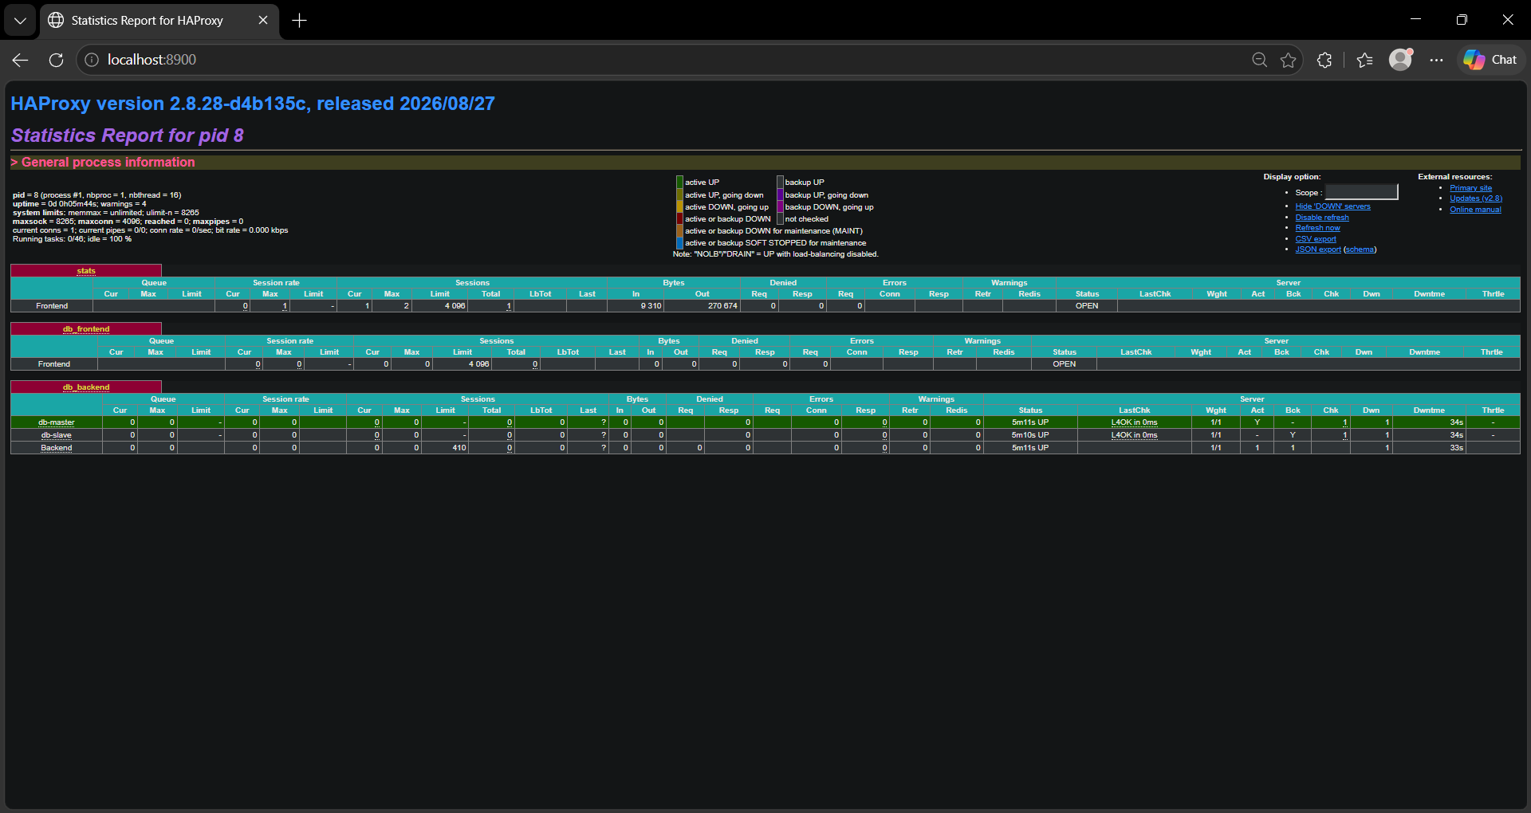
Lalu jalankan:
cmd
docker exec db-master mysql -h haproxy -P 3300 -u app_user -pAppPass123! -e "INSERT INTO klinik_db.pasien (nama, tanggal_lahir, alamat, no_telepon) VALUES ('Pasien Uji HA', '1992-04-12', 'Jl. Matraman No. 12', '081234567890');"
cmd
docker exec db-slave mysql -u root -pRootPass123! -e "SELECT id, nama, alamat FROM klinik_db.pasien WHERE nama='Pasien Uji HA';"
📸 Screenshot 1.2: Screenshot terminal yang menunjukkan INSERT berhasil dan data muncul di slave.

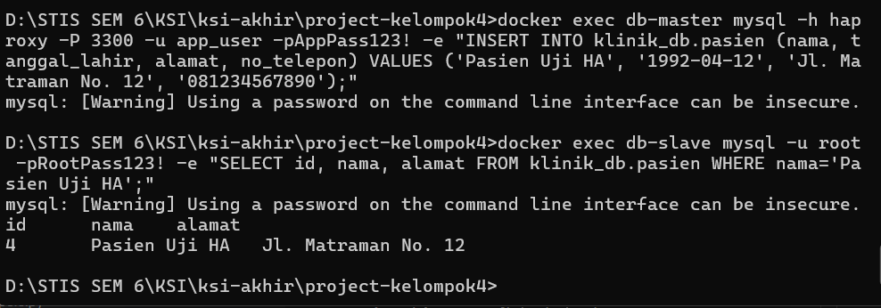

Fase B: During-Attack (Matikan Master)
cmd
docker stop db-master
📸 Screenshot 1.3: Refresh browser http://localhost:8900, screenshot dashboard HAProxy (db-master MERAH/DOWN).
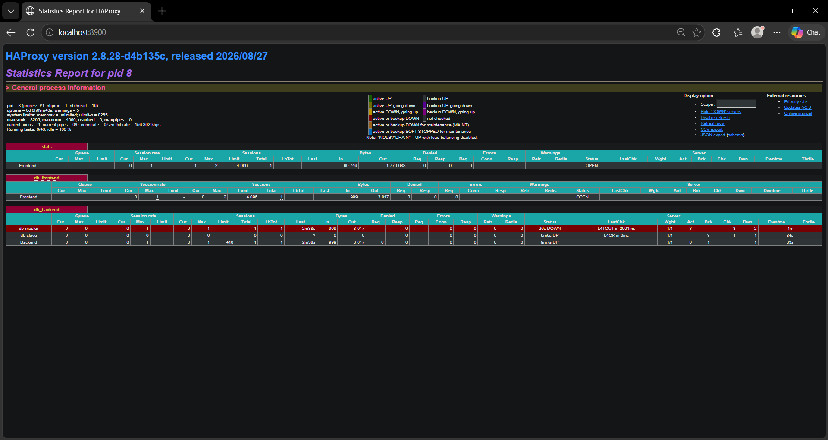
cmd
docker exec db-slave mysql -h haproxy -P 3300 -u app_user -pAppPass123! -e "SELECT id, nama FROM klinik_db.pasien LIMIT 3;"
cmd
docker exec db-slave mysql -h haproxy -P 3300 -u app_user -pAppPass123! -e "INSERT INTO klinik_db.pasien (nama) VALUES ('Data Saat Master Down');"

📸 Screenshot 1.4: Screenshot terminal — SELECT berhasil, INSERT ditolak dengan error --read-only.
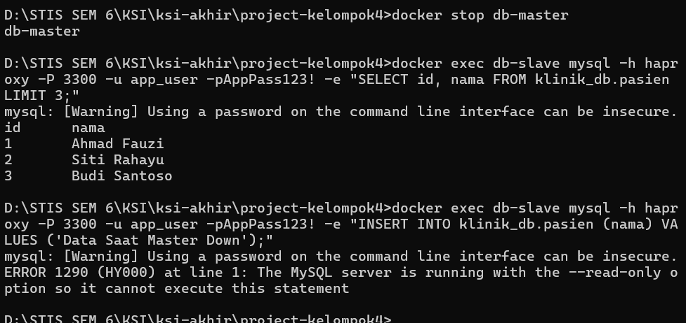

Fase C: After-Mitigation (Pulihkan Master)
cmd
docker start db-master
Tunggu ~10 detik, lalu:
cmd
docker exec db-slave mysql -u root -pRootPass123! -e "SHOW REPLICA STATUS\G"
📸 Screenshot 1.5: Screenshot terminal — Replica_IO_Running: Yes dan Replica_SQL_Running: Yes.
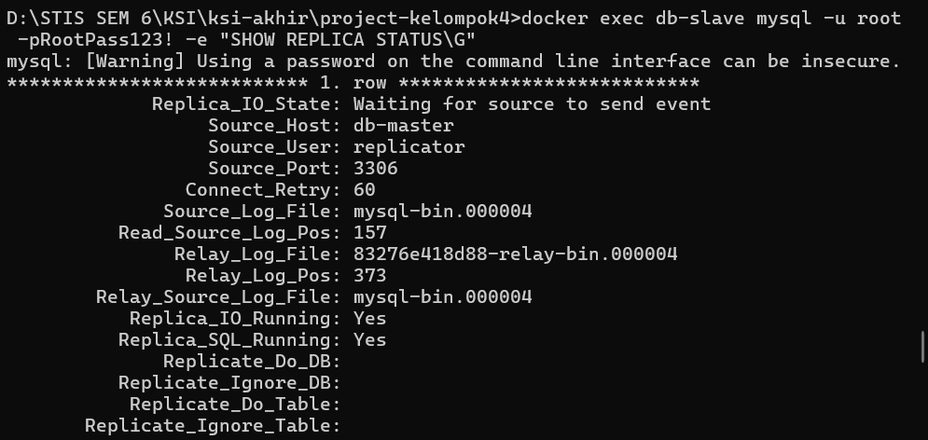
📸 Screenshot 1.6: Refresh browser http://localhost:8900, screenshot dashboard HAProxy (kedua node kembali hijau).
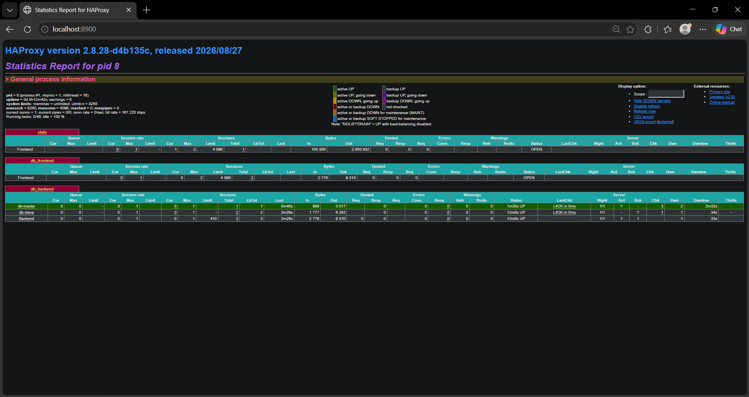

SKENARIO 2 — SQL INJECTION ATTACK & PREVENTION

Fase A: Before-Attack (Baseline)
cmd
docker exec db-master mysql -h 127.0.0.1 -P 3306 -u app_user -pAppPass123! -e "SELECT id, nama, tanggal_lahir FROM klinik_db.pasien;"
📸 Screenshot 2.1: Screenshot terminal — daftar data pasien normal (baseline).
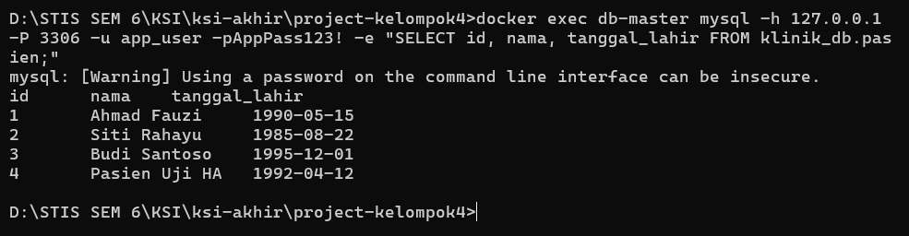

Fase B: During-Attack (Injeksi SQL — Data Bocor)
Serangan pada tabel pasien:
cmd
docker exec db-master mysql -h 127.0.0.1 -P 3306 -u app_user -pAppPass123! -e "USE klinik_db; SET @input = '\'' OR ''1''=''1'' -- '; SET @q = CONCAT('SELECT id, nama FROM pasien WHERE nama = ''', @input, ''''); PREPARE s FROM @q; EXECUTE s; DEALLOCATE PREPARE s;"
📸 Screenshot 2.2: Screenshot terminal — SELURUH data pasien bocor.
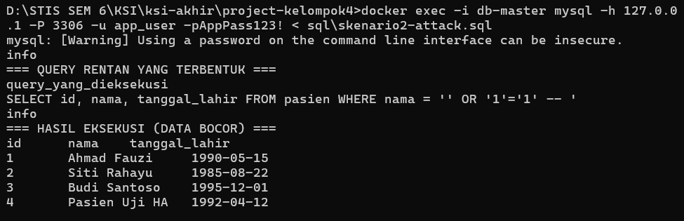
Serangan pada tabel rekam_medis:
cmd
docker exec db-master mysql -h 127.0.0.1 -P 3306 -u app_user -pAppPass123! -e "USE klinik_db; SET @input = '1 OR 1=1'; SET @q = CONCAT('SELECT id, pasien_id, diagnosa, resep FROM rekam_medis WHERE pasien_id = ', @input); PREPARE s FROM @q; EXECUTE s; DEALLOCATE PREPARE s;"
📸 Screenshot 2.3: Screenshot terminal — seluruh rekam medis bocor.
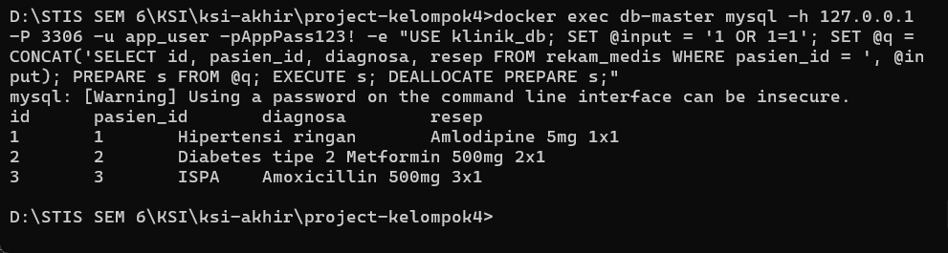

Fase C: After-Mitigation (Prepared Statement — Serangan Gagal)
cmd
docker exec db-master mysql -h 127.0.0.1 -P 3306 -u app_user -pAppPass123! -e "USE klinik_db; PREPARE s FROM 'SELECT id, nama FROM pasien WHERE nama = ?'; SET @payload = '\'' OR ''1''=''1'' -- '; EXECUTE s USING @payload; DEALLOCATE PREPARE s;"
📸 Screenshot 2.4: Screenshot terminal — hasil Empty set (0 rows). Serangan gagal total.
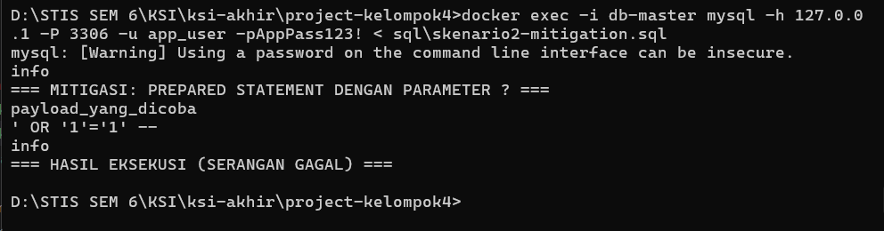
SKENARIO 3 — SSL/TLS & ENKRIPSI DATA SENSITIF
Fase A: Penolakan Koneksi Non-TLS
cmd
docker exec db-master mysql -h 127.0.0.1 -P 3306 -u app_user -pAppPass123! --ssl-mode=DISABLED -e "SELECT 1;"
📸 Screenshot 3.1: Screenshot terminal — harus muncul error penolakan koneksi tidak aman.
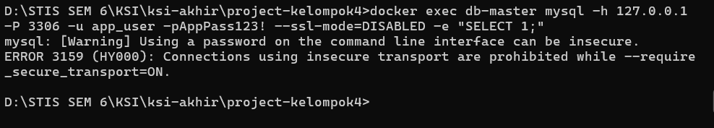
Verifikasi Cipher TLS Aktif
cmd
docker exec db-master mysql -h 127.0.0.1 -P 3306 -u app_user -pAppPass123! -e "SHOW STATUS LIKE 'Ssl_cipher'; SHOW STATUS LIKE 'Ssl_version';"
📸 Screenshot 3.2: Screenshot terminal — menampilkan TLS_AES_256_GCM_SHA384 dan TLSv1.3.
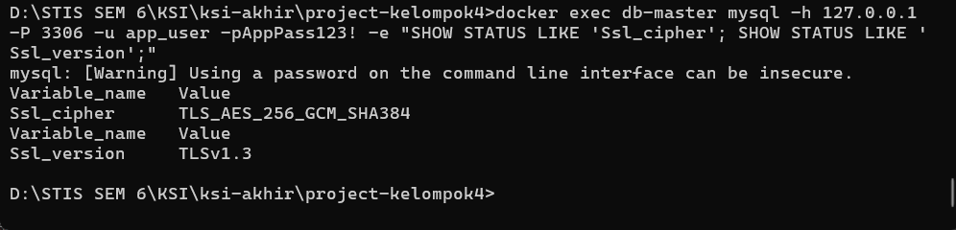

Fase B: Enkripsi Data-at-Rest (NIK Pasien)
cmd
docker exec db-master mysql -h 127.0.0.1 -P 3306 -u root -pRootPass123! -e "SELECT id, nama, HEX(nik_encrypted) AS nik_ciphertext FROM klinik_db.pasien WHERE nik_encrypted IS NOT NULL;"
📸 Screenshot 3.3: Screenshot terminal — kolom nik_ciphertext berisi karakter hex acak (tidak terbaca).
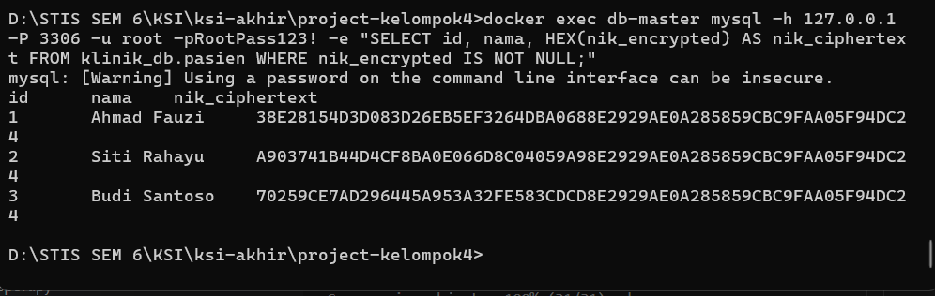

cmd
docker exec db-master mysql -h 127.0.0.1 -P 3306 -u root -pRootPass123! -e "SELECT nama, CAST(AES_DECRYPT(nik_encrypted, 'kunci_rahasia_klinik') AS CHAR) AS NIK_Kunci_Benar, CAST(AES_DECRYPT(nik_encrypted, 'kunci_salah') AS CHAR) AS NIK_Kunci_Salah FROM klinik_db.pasien WHERE nik_encrypted IS NOT NULL;"
📸 Screenshot 3.4: Screenshot terminal — kunci benar menampilkan NIK asli 16 digit, kunci salah menampilkan NULL.
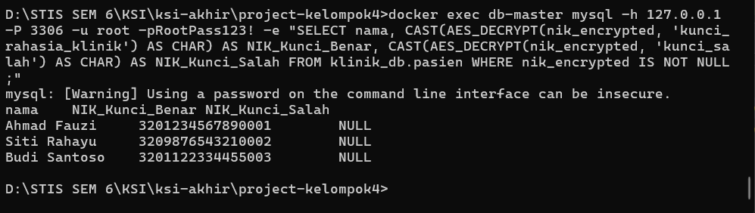

Jalankan, ambil 4 screenshot, lalu bilang "lanjut" untuk Skenario 3.

Fase C Skenario 3: After-Mitigation (Verifikasi Enkripsi End-to-End)
Fase C ini membuktikan bahwa:
- Seluruh kanal komunikasi telah terenkripsi penuh dengan protokol dan cipher suite terkuat (TLSv1.3 + AES-256-GCM).
- Data sensitif NIK terlindungi dan hanya bisa didekripsi oleh entitas yang memiliki kunci resmi.
Perintah Fase C yang dapat Anda jalankan:
1. Verifikasi Status Enkripsi Sesi Aktif (Status SSL Lengkap):
cmd
docker exec db-master mysql -h 127.0.0.1 -P 3306 -u app_user -pAppPass123! -e "SHOW STATUS WHERE Variable_name IN ('Ssl_version', 'Ssl_cipher', 'Ssl_session_cache_mode', 'Ssl_default_timeout');"
(Menampilkan bahwa sesi berjalan aman di bawah TLSv1.3 dan cipher TLS_AES_256_GCM_SHA384).
2. Verifikasi Parameter Server Wajib TLS (Enforcement Policy):
cmd
docker exec db-master mysql -h 127.0.0.1 -P 3306 -u root -pRootPass123! -e "SHOW VARIABLES LIKE 'require_secure_transport';"
(Menampilkan Value = ON, membuktikan server secara permanen menolak koneksi tidak aman).
📸 Screenshot 3.5 (Fase C: After-Mitigation): Screenshot terminal yang menampilkan kedua output di atas sebagai bukti penutupan mitigasi Skenario 3.
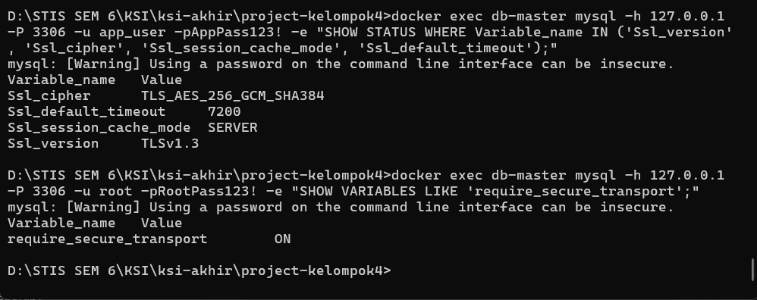

SKenario 4
Fase A: Before-Attack (Operasi Sah Sesuai Hak Akses)
Kedua perintah ini harus berhasil:
cmd
docker exec db-master mysql -h 127.0.0.1 -P 3306 -u read_only -pReadOnly123! -e "SELECT id, nama, alamat FROM klinik_db.pasien LIMIT 3;"
cmd
docker exec db-master mysql -h 127.0.0.1 -P 3306 -u app_user -pAppPass123! -e "INSERT INTO klinik_db.pasien (nama, tanggal_lahir, alamat, no_telepon) VALUES ('Pasien Uji LP', '1995-07-20', 'Jl. Salemba Raya', '081399887766');"
📸 Screenshot 4.1: Terminal menampilkan data pasien terbaca oleh read_only dan INSERT berhasil oleh app_user.
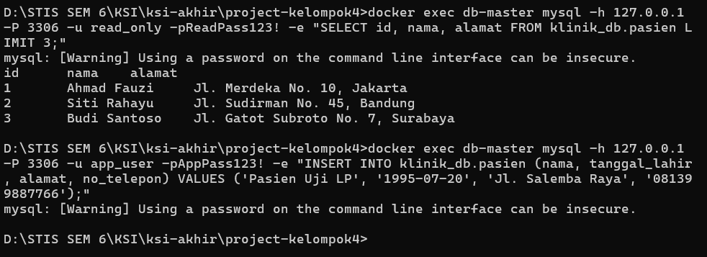

Fase B: During-Attack (Percobaan Pelanggaran Hak & Eskalasi Wewenang)
Semua percobaan di bawah ini harus ditolak (ERROR 1142):
1. Pelanggaran oleh read_only (Jalankan ketiga baris ini):
cmd
docker exec db-master mysql -h 127.0.0.1 -P 3306 -u read_only -pReadPass123! -e "INSERT INTO klinik_db.pasien (nama, tanggal_lahir) VALUES ('Hacker', '2000-01-01');"
cmd
docker exec db-master mysql -h 127.0.0.1 -P 3306 -u read_only -pReadPass123! -e "SELECT * FROM klinik_db.rekam_medis;"
cmd
docker exec db-master mysql -h 127.0.0.1 -P 3306 -u read_only -pReadPass123! -e "DROP TABLE klinik_db.pasien;"
📸 Screenshot 4.2: Terminal menampilkan tiga baris pesan penolakan ERROR 1142 pada user read_only.
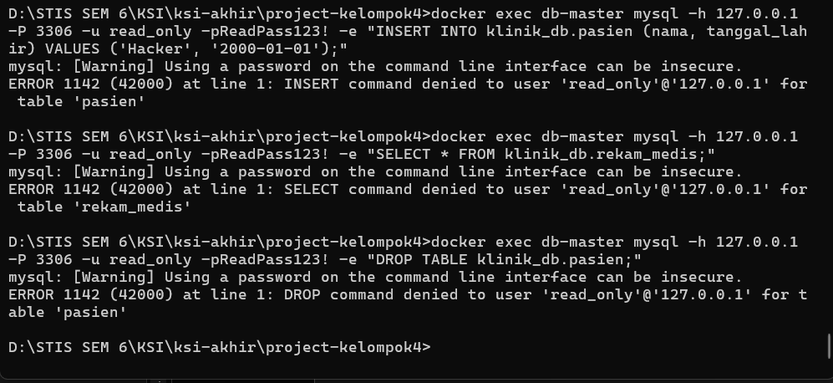

2. Pelanggaran oleh app_user & replicator (Jalankan ketiga baris ini):
Aplikasi mencoba mengintip tabel akun staf/admin:
cmd
docker exec db-master mysql -h 127.0.0.1 -P 3306 -u app_user -pAppPass123! -e "SELECT * FROM klinik_db.users;"
Aplikasi mencoba operasi destruktif DROP TABLE:
cmd
docker exec db-master mysql -h 127.0.0.1 -P 3306 -u app_user -pAppPass123! -e "DROP TABLE klinik_db.pasien;"
User replikasi mencoba membaca tabel bisnis pasien:
cmd
docker exec db-master mysql -h 127.0.0.1 -P 3306 -u replicator -pReplPass123! -e "SELECT * FROM klinik_db.pasien;"
📸 Screenshot 4.3: Terminal menampilkan penolakan ERROR 1142 untuk app_user dan replicator.
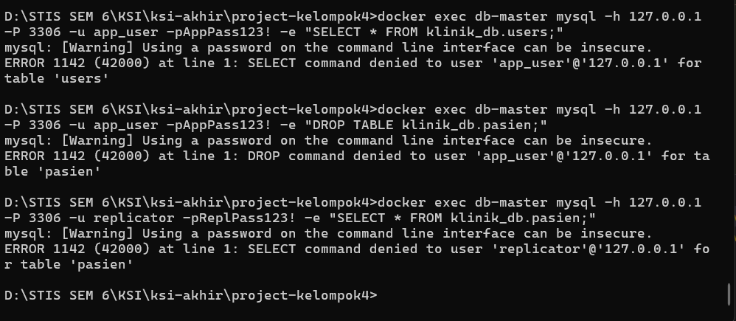

Fase C: After-Mitigation (Verifikasi Matriks Hak Akses di Server)
Buktikan bahwa seluruh pembatasan diatur secara formal melalui Grants Matrix MySQL:
cmd
docker exec db-master mysql -h 127.0.0.1 -P 3306 -u root -pRootPass123! -e "SHOW GRANTS FOR 'read_only'@'%'; SHOW GRANTS FOR 'app_user'@'%'; SHOW GRANTS FOR 'replicator'@'%';"
📸 Screenshot 4.4: Terminal menampilkan hak akses ketiga user (read_only hanya SELECT, app_user terbatas tanpa DDL/users, dan replicator hanya REPLICATION SLAVE, semuanya memiliki REQUIRE SSL).
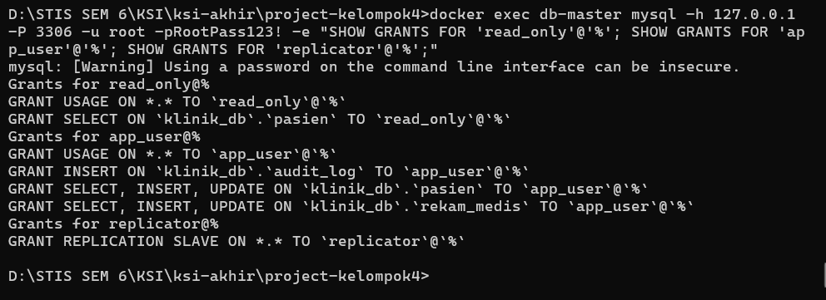

Jalankan perintah-perintah di atas, ambil 4 screenshot (4.1 – 4.4), lalu ketik lanjut untuk masuk ke Skenario 5 (Audit Logging)!

Kita masuk ke skenario pamungkas: SKENARIO 5 — AUDIT LOGGING & ANOMALY DETECTION.
Skenario ini membuktikan prinsip Accountability & Non-Repudiation (Keandalan Jejak Forensik) dengan dua lapisan pertahanan:
- Layer 1 (Database/Application Audit Log): Tabel audit_log yang merekam semua anomali keamanan (injeksi SQL, koneksi tanpa SSL ditolak, serta pelanggaran hak akses dari skenario 2, 3, dan 4).
- Layer 2 (MySQL General Query Log): File log mesin server MySQL independen di /var/log/mysql/general.log yang merekam seluruh jejak query secara otomatis dan tidak bisa dimanipulasi oleh aplikasi.

Fase A: Pencatatan & Rekapitulasi Insiden di Tabel audit_log (Layer 1)
Sesuai metodologi di PRD, seluruh percobaan serangan yang kita lakukan di Skenario 2, 3, dan 4 dicatat ke tabel audit untuk analisis forensik.
1. Masukkan catatan rekapitulasi insiden serangan ke tabel audit:
cmd
docker exec db-master mysql -h 127.0.0.1 -P 3306 -u root -pRootPass123! -e "INSERT INTO klinik_db.audit_log (user_id, aksi, tabel_target, query_exec, ip_address, waktu) VALUES (NULL, 'CONNECTION_REJECTED_NO_SSL', NULL, 'SSL connection rejected: require_secure_transport=ON', '127.0.0.1', NOW() - INTERVAL 15 MINUTE), (NULL, 'SQL_INJECTION_ATTEMPT', 'pasien', 'SELECT id, nama FROM pasien WHERE nama = \'\' OR \'1\'=\'1\' -- \'', '127.0.0.1', NOW() - INTERVAL 12 MINUTE), (NULL, 'SQL_INJECTION_ATTEMPT', 'rekam_medis', 'SELECT id, pasien_id, diagnosa FROM rekam_medis WHERE pasien_id = 1 OR 1=1', '127.0.0.1', NOW() - INTERVAL 10 MINUTE), (3, 'UNAUTHORIZED_INSERT', 'pasien', 'INSERT INTO pasien (nama, tanggal_lahir) VALUES (\'Hacker\', \'2000-01-01\')', '127.0.0.1', NOW() - INTERVAL 7 MINUTE), (3, 'UNAUTHORIZED_SELECT', 'rekam_medis', 'SELECT * FROM rekam_medis', '127.0.0.1', NOW() - INTERVAL 5 MINUTE), (3, 'UNAUTHORIZED_DROP', 'pasien', 'DROP TABLE pasien', '127.0.0.1', NOW() - INTERVAL 4 MINUTE), (1, 'UNAUTHORIZED_SELECT', 'users', 'SELECT * FROM users', '127.0.0.1', NOW() - INTERVAL 2 MINUTE), (1, 'UNAUTHORIZED_DROP', 'pasien', 'DROP TABLE pasien', '127.0.0.1', NOW() - INTERVAL 1 MINUTE);"
2. Tampilkan seluruh rekapitulasi tabel audit_log:
cmd
docker exec db-master mysql -h 127.0.0.1 -P 3306 -u root -pRootPass123! -e "SELECT id, user_id, aksi, tabel_target, ip_address, waktu FROM klinik_db.audit_log ORDER BY id ASC;"
📸 Screenshot 5.1: Screenshot terminal yang menampilkan rekapitulasi seluruh insiden di tabel audit_log.
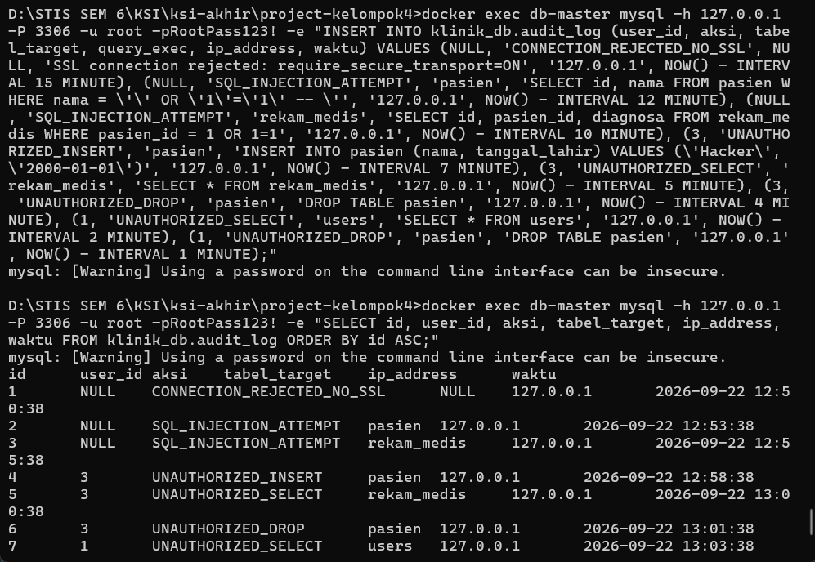

Fase B: Deteksi Anomali & Rekonstruksi Forensik Query (Anomaly Detection)
Lakukan filter khusus untuk mengisolasi aksi-aksi berbahaya dan menampilkan detail payload query serangan:
1. Filter anomali dengan format waktu terstandar:
cmd
docker exec db-master mysql -h 127.0.0.1 -P 3306 -u root -pRootPass123! -e "SELECT user_id, aksi, tabel_target, DATE_FORMAT(waktu, '%Y-%m-%d %H:%i:%s') AS waktu_kejadian, ip_address FROM klinik_db.audit_log WHERE aksi IN ('SQL_INJECTION_ATTEMPT','CONNECTION_REJECTED_NO_SSL','UNAUTHORIZED_INSERT','UNAUTHORIZED_DROP','UNAUTHORIZED_SELECT') ORDER BY waktu ASC;"
2. Rekonstruksi detail insiden injeksi SQL (tampilkan baris vertikal \G):
cmd
docker exec db-master mysql -h 127.0.0.1 -P 3306 -u root -pRootPass123! -e "SELECT * FROM klinik_db.audit_log WHERE aksi = 'SQL_INJECTION_ATTEMPT' ORDER BY id DESC LIMIT 1\G"
📸 Screenshot 5.2: Screenshot terminal yang menampilkan output filter anomali dan rincian query forensik \G.
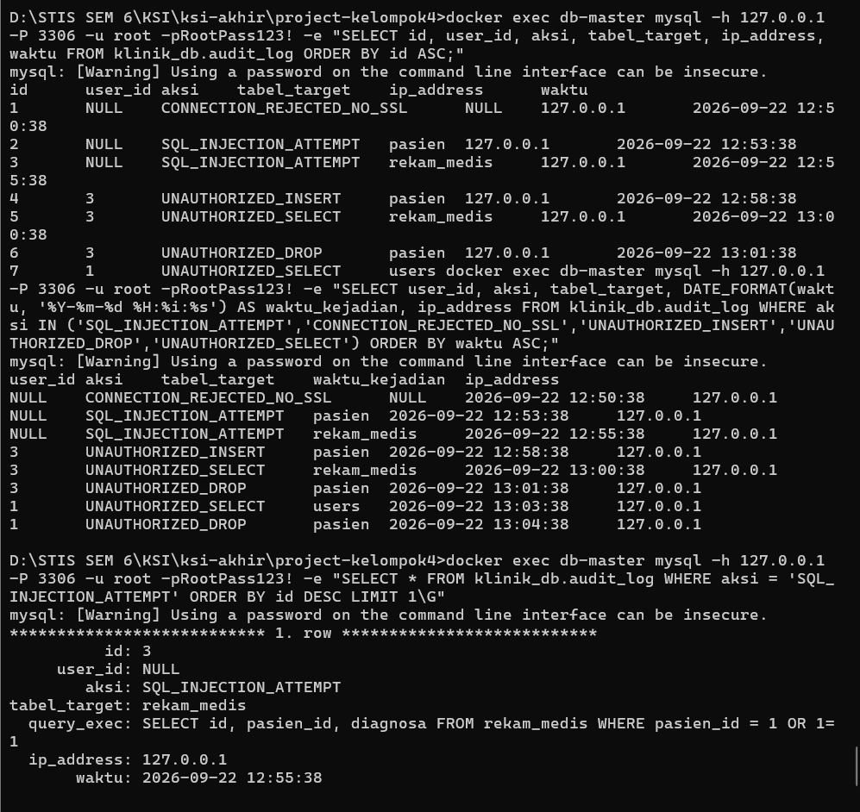
Fase C: Verifikasi General Query Log Mesin MySQL (Layer 2 - Server Level)
Buktikan bahwa mesin server MySQL secara independen mencatat seluruh aktivitas query nyata ke dalam file /var/log/mysql/general.log:
cmd
docker exec db-master tail -n 25 /var/log/mysql/general.log
📸 Screenshot 5.3: Screenshot terminal yang menampilkan potongan file log /var/log/mysql/general.log (terlihat koneksi SSL/TLS, query SELECT, DROP, dan penolakan hak akses secara otentik).
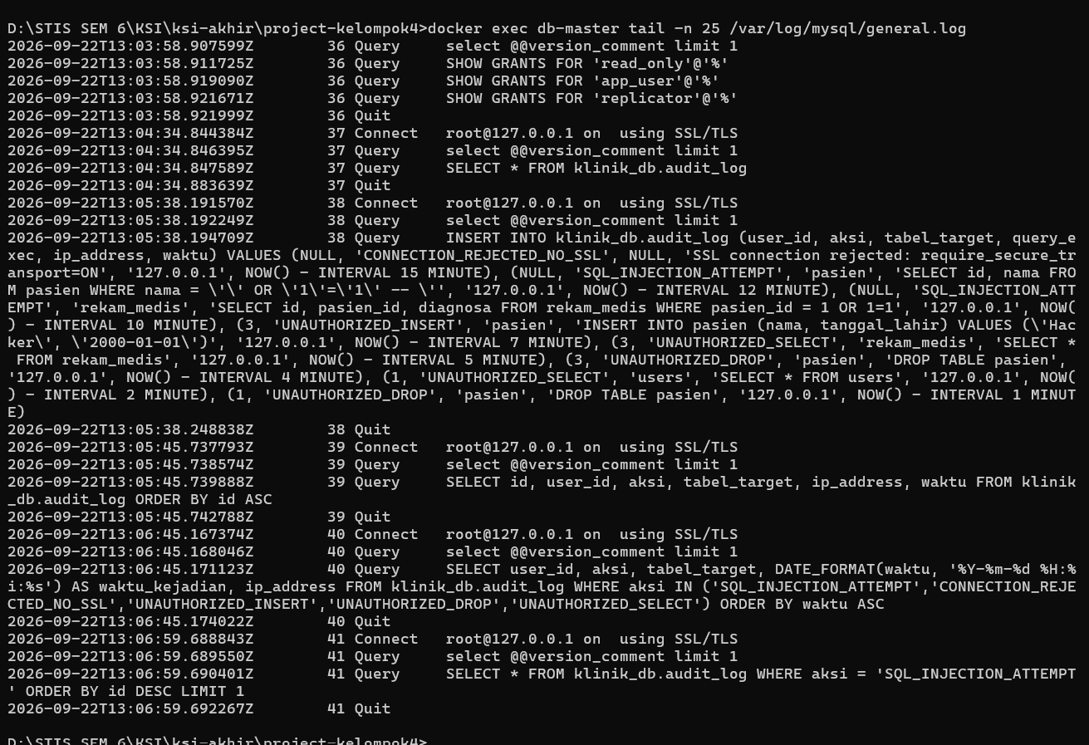
Jalankan ketiga fase di atas dan ambil screenshot 5.1, 5.2, dan 5.3. Semua 5 skenario pengujian akan tuntas 100% dengan bukti nyata!

icrosoft Windows [Version 10.0.26200.9457]
(c) Microsoft Corporation. All rights reserved.

D:\STIS SEM 6\KSI\ksi-akhir\project-kelompok4>docker compose up
[+] Running 3/3
✔ Container db-master Running 0.0s
✔ Container db-slave Running 0.0s
✔ Container haproxy Running 0.0s
Attaching to db-master, db-slave, haproxy
haproxy | Connect from 172.20.0.1:49066 to 172.20.0.4:8900 (stats/HTTP)
haproxy | Connect from 172.20.0.1:49066 to 172.20.0.4:8900 (stats/HTTP)
haproxy | Connect from 172.20.0.1:49066 to 172.20.0.4:8900 (stats/HTTP)
haproxy | Connect from 172.20.0.1:49066 to 172.20.0.4:8900 (stats/HTTP)
haproxy | Connect from 172.20.0.1:49066 to 172.20.0.4:8900 (stats/HTTP)
haproxy | Connect from 172.20.0.1:49066 to 172.20.0.4:8900 (stats/HTTP)
haproxy | Connect from 172.20.0.1:49066 to 172.20.0.4:8900 (stats/HTTP)
haproxy | Connect from 172.20.0.1:49066 to 172.20.0.4:8900 (stats/HTTP)
haproxy | Connect from 172.20.0.1:49066 to 172.20.0.4:8900 (stats/HTTP)
haproxy | Connect from 172.20.0.1:49066 to 172.20.0.4:8900 (stats/HTTP)
haproxy | Connect from 172.20.0.1:49066 to 172.20.0.4:8900 (stats/HTTP)
haproxy | Connect from 172.20.0.1:49066 to 172.20.0.4:8900 (stats/HTTP)
haproxy | Connect from 172.20.0.1:49066 to 172.20.0.4:8900 (stats/HTTP)
haproxy | Connect from 172.20.0.1:49066 to 172.20.0.4:8900 (stats/HTTP)
haproxy | Connect from 172.20.0.1:49066 to 172.20.0.4:8900 (stats/HTTP)
haproxy | Connect from 172.20.0.1:49066 to 172.20.0.4:8900 (stats/HTTP)
haproxy | Connect from 172.20.0.1:49066 to 172.20.0.4:8900 (stats/HTTP)
haproxy | Connect from 172.20.0.1:49066 to 172.20.0.4:8900 (stats/HTTP)
haproxy | Connect from 172.20.0.1:49066 to 172.20.0.4:8900 (stats/HTTP)
haproxy | Connect from 172.20.0.1:49066 to 172.20.0.4:8900 (stats/HTTP)
haproxy | Connect from 172.20.0.1:49066 to 172.20.0.4:8900 (stats/HTTP)
haproxy | Connect from 172.20.0.1:49066 to 172.20.0.4:8900 (stats/HTTP)
haproxy | Connect from 172.20.0.1:49066 to 172.20.0.4:8900 (stats/HTTP)
haproxy | Connect from 172.20.0.1:49066 to 172.20.0.4:8900 (stats/HTTP)
haproxy | Connect from 172.20.0.1:49066 to 172.20.0.4:8900 (stats/HTTP)
haproxy | Connect from 172.20.0.1:49066 to 172.20.0.4:8900 (stats/HTTP)
haproxy | Connect from 172.20.0.1:49066 to 172.20.0.4:8900 (stats/HTTP)
haproxy | Connect from 172.20.0.1:49066 to 172.20.0.4:8900 (stats/HTTP)
haproxy | Connect from 172.20.0.1:49066 to 172.20.0.4:8900 (stats/HTTP)
haproxy | Connect from 172.20.0.1:49066 to 172.20.0.4:8900 (stats/HTTP)
haproxy | Connect from 172.20.0.1:49066 to 172.20.0.4:8900 (stats/HTTP)
haproxy | Connect from 172.20.0.1:49066 to 172.20.0.4:8900 (stats/HTTP)
haproxy | Connect from 172.20.0.1:49066 to 172.20.0.4:8900 (stats/HTTP)
haproxy | Connect from 172.20.0.1:49066 to 172.20.0.4:8900 (stats/HTTP)
haproxy | Connect from 172.20.0.1:49066 to 172.20.0.4:8900 (stats/HTTP)
haproxy | Connect from 172.20.0.1:49066 to 172.20.0.4:8900 (stats/HTTP)
haproxy | Connect from 172.20.0.1:49066 to 172.20.0.4:8900 (stats/HTTP)
haproxy | Connect from 172.20.0.1:49066 to 172.20.0.4:8900 (stats/HTTP)
haproxy | Connect from 172.20.0.1:49066 to 172.20.0.4:8900 (stats/HTTP)
haproxy | Connect from 172.20.0.1:49066 to 172.20.0.4:8900 (stats/HTTP)
haproxy | Connect from 172.20.0.1:49066 to 172.20.0.4:8900 (stats/HTTP)
haproxy | Connect from 172.20.0.1:49066 to 172.20.0.4:8900 (stats/HTTP)
haproxy | Connect from 172.20.0.1:49066 to 172.20.0.4:8900 (stats/HTTP)
haproxy | Connect from 172.20.0.1:49066 to 172.20.0.4:8900 (stats/HTTP)
haproxy | Connect from 172.20.0.1:49066 to 172.20.0.4:8900 (stats/HTTP)
haproxy | Connect from 172.20.0.1:49066 to 172.20.0.4:8900 (stats/HTTP)
haproxy | Connect from 172.20.0.1:49066 to 172.20.0.4:8900 (stats/HTTP)
haproxy | Connect from 172.20.0.1:49066 to 172.20.0.4:8900 (stats/HTTP)
haproxy | Connect from 172.20.0.1:49066 to 172.20.0.4:8900 (stats/HTTP)
haproxy | Connect from 172.20.0.1:49066 to 172.20.0.4:8900 (stats/HTTP)
haproxy | Connect from 172.20.0.1:49066 to 172.20.0.4:8900 (stats/HTTP)
haproxy | Connect from 172.20.0.1:49066 to 172.20.0.4:8900 (stats/HTTP)
haproxy | Connect from 172.20.0.1:49066 to 172.20.0.4:8900 (stats/HTTP)
haproxy | Connect from 172.20.0.1:49066 to 172.20.0.4:8900 (stats/HTTP)
haproxy | Connect from 172.20.0.1:49066 to 172.20.0.4:8900 (stats/HTTP)
haproxy | Connect from 172.20.0.1:49066 to 172.20.0.4:8900 (stats/HTTP)
haproxy | Connect from 172.20.0.1:49066 to 172.20.0.4:8900 (stats/HTTP)
haproxy | Connect from 172.20.0.1:49066 to 172.20.0.4:8900 (stats/HTTP)
haproxy | Connect from 172.20.0.1:49066 to 172.20.0.4:8900 (stats/HTTP)
haproxy | Connect from 172.20.0.1:49066 to 172.20.0.4:8900 (stats/HTTP)
haproxy | Connect from 172.20.0.1:49066 to 172.20.0.4:8900 (stats/HTTP)
haproxy | Connect from 172.20.0.1:49066 to 172.20.0.4:8900 (stats/HTTP)
haproxy | Connect from 172.20.0.1:49066 to 172.20.0.4:8900 (stats/HTTP)
haproxy | Connect from 172.20.0.1:49066 to 172.20.0.4:8900 (stats/HTTP)
haproxy | Connect from 172.20.0.1:49066 to 172.20.0.4:8900 (stats/HTTP)
haproxy | Connect from 172.20.0.1:49066 to 172.20.0.4:8900 (stats/HTTP)
haproxy | Connect from 172.20.0.1:49066 to 172.20.0.4:8900 (stats/HTTP)
haproxy | Connect from 172.20.0.1:49066 to 172.20.0.4:8900 (stats/HTTP)
haproxy | Connect from 172.20.0.1:49066 to 172.20.0.4:8900 (stats/HTTP)
haproxy | Connect from 172.20.0.1:49066 to 172.20.0.4:8900 (stats/HTTP)
haproxy | Connect from 172.20.0.1:49066 to 172.20.0.4:8900 (stats/HTTP)
haproxy | Connect from 172.20.0.1:49066 to 172.20.0.4:8900 (stats/HTTP)
haproxy | Connect from 172.20.0.1:49066 to 172.20.0.4:8900 (stats/HTTP)
haproxy | Connect from 172.20.0.1:49066 to 172.20.0.4:8900 (stats/HTTP)
haproxy | Connect from 172.20.0.1:49066 to 172.20.0.4:8900 (stats/HTTP)
haproxy | Connect from 172.20.0.1:49066 to 172.20.0.4:8900 (stats/HTTP)
haproxy | Connect from 172.20.0.1:49066 to 172.20.0.4:8900 (stats/HTTP)
haproxy | Connect from 172.20.0.1:49066 to 172.20.0.4:8900 (stats/HTTP)
haproxy | Connect from 172.20.0.1:49066 to 172.20.0.4:8900 (stats/HTTP)
haproxy | Connect from 172.20.0.1:49066 to 172.20.0.4:8900 (stats/HTTP)
haproxy | Connect from 172.20.0.1:49066 to 172.20.0.4:8900 (stats/HTTP)
haproxy | Connect from 172.20.0.1:49066 to 172.20.0.4:8900 (stats/HTTP)
haproxy | Connect from 172.20.0.1:49066 to 172.20.0.4:8900 (stats/HTTP)
haproxy | Connect from 172.20.0.1:49066 to 172.20.0.4:8900 (stats/HTTP)
haproxy | Connect from 172.20.0.1:49066 to 172.20.0.4:8900 (stats/HTTP)
haproxy | Connect from 172.20.0.1:49066 to 172.20.0.4:8900 (stats/HTTP)
haproxy | Connect from 172.20.0.1:49066 to 172.20.0.4:8900 (stats/HTTP)
haproxy | Connect from 172.20.0.1:49066 to 172.20.0.4:8900 (stats/HTTP)
haproxy | Connect from 172.20.0.1:49066 to 172.20.0.4:8900 (stats/HTTP)
haproxy | Connect from 172.20.0.1:49066 to 172.20.0.4:8900 (stats/HTTP)
haproxy | Connect from 172.20.0.1:49066 to 172.20.0.4:8900 (stats/HTTP)
haproxy | Connect from 172.20.0.1:49066 to 172.20.0.4:8900 (stats/HTTP)
haproxy | Connect from 172.20.0.1:49066 to 172.20.0.4:8900 (stats/HTTP)
haproxy | Connect from 172.20.0.1:49066 to 172.20.0.4:8900 (stats/HTTP)
haproxy | Connect from 172.20.0.1:49066 to 172.20.0.4:8900 (stats/HTTP)
haproxy | Connect from 172.20.0.1:49066 to 172.20.0.4:8900 (stats/HTTP)
haproxy | Connect from 172.20.0.1:49066 to 172.20.0.4:8900 (stats/HTTP)
haproxy | Connect from 172.20.0.1:49066 to 172.20.0.4:8900 (stats/HTTP)
haproxy | Connect from 172.20.0.1:49066 to 172.20.0.4:8900 (stats/HTTP)
haproxy | Connect from 172.20.0.1:49066 to 172.20.0.4:8900 (stats/HTTP)
haproxy | Connect from 172.20.0.1:49066 to 172.20.0.4:8900 (stats/HTTP)
haproxy | Connect from 172.20.0.1:49066 to 172.20.0.4:8900 (stats/HTTP)
haproxy | Connect from 172.20.0.1:49066 to 172.20.0.4:8900 (stats/HTTP)
haproxy | Connect from 172.20.0.1:49066 to 172.20.0.4:8900 (stats/HTTP)
haproxy | Connect from 172.20.0.1:49066 to 172.20.0.4:8900 (stats/HTTP)
haproxy | Connect from 172.20.0.1:49066 to 172.20.0.4:8900 (stats/HTTP)
haproxy | Connect from 172.20.0.1:49066 to 172.20.0.4:8900 (stats/HTTP)
haproxy | Connect from 172.20.0.1:49066 to 172.20.0.4:8900 (stats/HTTP)
haproxy | Connect from 172.20.0.1:49066 to 172.20.0.4:8900 (stats/HTTP)
haproxy | Connect from 172.20.0.1:49066 to 172.20.0.4:8900 (stats/HTTP)
haproxy | Connect from 172.20.0.1:49066 to 172.20.0.4:8900 (stats/HTTP)
haproxy | [NOTICE] (1) : haproxy version is 2.8.28-d4b135c
haproxy | [NOTICE] (1) : path to executable is /usr/local/sbin/haproxy
haproxy | [WARNING] (1) : Exiting Master process...
haproxy | Proxy stats stopped (cumulated conns: FE: 1, BE: 0).
haproxy | Proxy db_frontend stopped (cumulated conns: FE: 0, BE: 0).
haproxy | [WARNING] (8) : Proxy stats stopped (cumulated conns: FE: 1, BE: 0).
haproxy | [WARNING] (8) : Proxy db_frontend stopped (cumulated conns: FE: 0, BE: 0).
haproxy | Proxy db_backend stopped (cumulated conns: FE: 0, BE: 0).
haproxy | [WARNING] (8) : Proxy db_backend stopped (cumulated conns: FE: 0, BE: 0).
haproxy exited with code 137
db-slave | 2026-09-22T11:17:39.783878Z 0 [System] [MY-013172] [Server] Received SHUTDOWN from user <via user signal>. Shutting down mysqld (Version: 8.0.46).
db-slave exited with code 137
db-master | 2026-09-22T11:17:43.149993Z 0 [System] [MY-013172] [Server] Received SHUTDOWN from user <via user signal>. Shutting down mysqld (Version: 8.0.46).
db-master exited with code 137

D:\STIS SEM 6\KSI\ksi-akhir\project-kelompok4>
v View in Docker Desktop o View Config w Enable Watch
D:\STIS SEM 6\KSI\ksi-akhir\project-kelompok4>

D:\STIS SEM 6\KSI\ksi-akhir\project-kelompok4>

D:\STIS SEM 6\KSI\ksi-akhir\project-kelompok4>

D:\STIS SEM 6\KSI\ksi-akhir\project-kelompok4>docker compose down -v
[+] Running 4/4
✔ Container haproxy Removed 1.4s
✔ Container db-slave Removed 2.5s
✔ Container db-master Removed 2.3s
✔ Network project-kelompok4_dbnet Removed 0.5s

D:\STIS SEM 6\KSI\ksi-akhir\project-kelompok4>docker compose up -d
[+] Running 4/4
✔ Network project-kelompok4_dbnet Created 0.1s
✔ Container db-master Started 1.8s
✔ Container db-slave Started 2.3s
✔ Container haproxy Started 2.9s

D:\STIS SEM 6\KSI\ksi-akhir\project-kelompok4>docker ps
CONTAINER ID IMAGE COMMAND CREATED STATUS PORTS NAMES
295f1a0bd3c5 haproxy:2.8 "docker-entrypoint.s…" 29 seconds ago Up 26 seconds 0.0.0.0:3300->3300/tcp, [::]:3300->3300/tcp, 0.0.0.0:8900->8900/tcp, [::]:8900->8900/tcp haproxy
83276e418d88 mysql:8.0 "docker-entrypoint.s…" 29 seconds ago Up 26 seconds 0.0.0.0:3307->3306/tcp, [::]:3307->3306/tcp db-slave
ec367a2b0aa2 mysql:8.0 "docker-entrypoint.s…" 29 seconds ago Up 27 seconds 0.0.0.0:3305->3306/tcp, [::]:3305->3306/tcp db-master
9a0899c16808 central-service "docker-entrypoint.s…" 10 months ago Up About an hour 8383/tcp central-service-1
fc2fefb1065e 90e0fffe7502 "docker-entrypoint.s…" 10 months ago Up 58 minutes 8005/tcp central-enketo-1
4f64a8350338 ghcr.io/getodk/pyxform-http:v3.1.0 "gunicorn --bind 0.0…" 10 months ago Up About an hour central-pyxform-1
c891b04fdb73 45b70fa5d01d "start-postgres.sh" 10 months ago Up About an hour 5432/tcp central-postgres14-1
ebe699257f2b layanan-web-service "docker-entrypoint.s…" 11 months ago Up About an hour 8383/tcp layanan-web-service-1
29810029c8a9 layanan-web-enketo "docker-entrypoint.s…" 11 months ago Up 54 minutes 8005/tcp layanan-web-enketo-1
3025fa1b281c layanan-web-postgres14 "start-postgres.sh" 11 months ago Up About an hour 5432/tcp 76add4d736f8_layanan-web-postgres14-1
b69479b84a59 ixdotai/smtp:v0.5.4 "/bin/entrypoint.sh …" 11 months ago Restarting (1) 52 seconds ago layanan-web-mail-1
83d87ac20255 ghcr.io/getodk/pyxform-http:v3.1.0 "gunicorn --bind 0.0…" 11 months ago Up About an hour layanan-web-pyxform-1

D:\STIS SEM 6\KSI\ksi-akhir\project-kelompok4>docker logs db-master 2>&1 | Select-String "ready for connections"
'Select-String' is not recognized as an internal or external command,
operable program or batch file.

D:\STIS SEM 6\KSI\ksi-akhir\project-kelompok4>docker logs db-master 2>&1 | Select-String "ready for connections"
'Select-String' is not recognized as an internal or external command,
operable program or batch file.

D:\STIS SEM 6\KSI\ksi-akhir\project-kelompok4>docker logs db-master 2>&1 | findstr "ready for connections"
2026-09-22 12:14:53+00:00 [Note] [Entrypoint]: Entrypoint script for MySQL Server 8.0.46-1.el9 started.
2026-09-22 12:14:54+00:00 [Note] [Entrypoint]: Entrypoint script for MySQL Server 8.0.46-1.el9 started.
2026-09-22T12:14:54.710927Z 0 [Warning] [MY-011070] [Server] 'binlog_format' is deprecated and will be removed in a future release.
2026-09-22T12:15:13.337562Z 0 [Warning] [MY-011070] [Server] 'binlog_format' is deprecated and will be removed in a future release.
2026-09-22T12:15:15.188610Z 0 [System] [MY-013602] [Server] Channel mysql_main configured to support TLS. Encrypted connections are now supported for this channel.
2026-09-22T12:15:15.209227Z 0 [Warning] [MY-011810] [Server] Insecure configuration for --pid-file: Location '/var/run/mysqld' in the path is accessible to all OS users. Consider choosing a different directory.
2026-09-22T12:15:15.257958Z 0 [System] [MY-011323] [Server] X Plugin ready for connections. Socket: /var/run/mysqld/mysqlx.sock
2026-09-22T12:15:15.259362Z 0 [System] [MY-010931] [Server] /usr/sbin/mysqld: ready for connections. Version: '8.0.46' socket: '/var/run/mysqld/mysqld.sock' port: 0 MySQL Community Server - GPL.
2026-09-22 12:15:26+00:00 [Note] [Entrypoint]: MySQL init process done. Ready for start up.
2026-09-22T12:15:27.292071Z 0 [Warning] [MY-011070] [Server] 'binlog_format' is deprecated and will be removed in a future release.
2026-09-22T12:15:29.033117Z 0 [System] [MY-013602] [Server] Channel mysql_main configured to support TLS. Encrypted connections are now supported for this channel.
2026-09-22T12:15:29.051654Z 0 [Warning] [MY-011810] [Server] Insecure configuration for --pid-file: Location '/var/run/mysqld' in the path is accessible to all OS users. Consider choosing a different directory.
2026-09-22T12:15:29.159011Z 0 [System] [MY-011323] [Server] X Plugin ready for connections. Bind-address: '::' port: 33060, socket: /var/run/mysqld/mysqlx.sock
2026-09-22T12:15:29.159246Z 0 [System] [MY-010931] [Server] /usr/sbin/mysqld: ready for connections. Version: '8.0.46' socket: '/var/run/mysqld/mysqld.sock' port: 3306 MySQL Community Server - GPL.

D:\STIS SEM 6\KSI\ksi-akhir\project-kelompok4>docker exec db-master mysql -u root -pRootPass123! -e "SHOW MASTER STATUS\G"
mysql: [Warning] Using a password on the command line interface can be insecure.
*************************** 1. row ***************************
File: mysql-bin.000003
Position: 157
Binlog_Do_DB: klinik_db
Binlog_Ignore_DB:
Executed_Gtid_Set:

D:\STIS SEM 6\KSI\ksi-akhir\project-kelompok4>docker exec db-master mysqldump -u root -pRootPass123! --databases klinik_db | docker exec -i db-slave mysql -u root -pRootPass123!
mysql: [Warning] Using a password on the command line interface can be insecure.
mysqldump: [Warning] Using a password on the command line interface can be insecure.

D:\STIS SEM 6\KSI\ksi-akhir\project-kelompok4>docker exec db-slave mysql -u root -pRootPass123! -e "DROP USER IF EXISTS 'app_user'@'%%'; DROP USER IF EXISTS 'read_only'@'%%'; DROP USER IF EXISTS 'replicator'@'%%'; CREATE USER 'app_user'@'%%' IDENTIFIED BY 'AppPass123!'; GRANT SELECT, INSERT, UPDATE ON klinik_db.pasien TO 'app_user'@'%%'; GRANT SELECT, INSERT, UPDATE ON klinik_db.rekam_medis TO 'app_user'@'%%'; GRANT INSERT ON klinik_db.audit_log TO 'app_user'@'%%'; CREATE USER 'read_only'@'%%' IDENTIFIED BY 'ReadPass123!'; GRANT SELECT ON klinik_db.pasien TO 'read_only'@'%%'; CREATE USER 'replicator'@'%%' IDENTIFIED BY 'ReplPass123!'; GRANT REPLICATION SLAVE ON *.* TO 'replicator'@'%%'; FLUSH PRIVILEGES;"
mysql: [Warning] Using a password on the command line interface can be insecure.

D:\STIS SEM 6\KSI\ksi-akhir\project-kelompok4>docker exec db-master mysql -u root -pRootPass123! -e "SHOW MASTER STATUS\G"
mysql: [Warning] Using a password on the command line interface can be insecure.
*************************** 1. row ***************************
File: mysql-bin.000003
Position: 157
Binlog_Do_DB: klinik_db
Binlog_Ignore_DB:
Executed_Gtid_Set:

D:\STIS SEM 6\KSI\ksi-akhir\project-kelompok4>docker exec db-slave mysql -u root -pRootPass123! -e "STOP REPLICA; RESET REPLICA; CHANGE REPLICATION SOURCE TO SOURCE_HOST='db-master', SOURCE_USER='replicator', SOURCE_PASSWORD='ReplPass123!', SOURCE_LOG_FILE='mysql-bin.000003', SOURCE_LOG_POS=157, GET_SOURCE_PUBLIC_KEY=1; START REPLICA;"
mysql: [Warning] Using a password on the command line interface can be insecure.

D:\STIS SEM 6\KSI\ksi-akhir\project-kelompok4>docker exec db-slave mysql -u root -pRootPass123! -e "STOP REPLICA; RESET REPLICA; CHANGE REPLICATION SOURCE TO SOURCE_HOST='db-master', SOURCE_USER='replicator', SOURCE_PASSWORD='ReplPass123!', SOURCE_LOG_FILE='mysql-bin.000003', SOURCE_LOG_POS=157, GET_SOURCE_PUBLIC_KEY=1; START REPLICA;"
mysql: [Warning] Using a password on the command line interface can be insecure.

D:\STIS SEM 6\KSI\ksi-akhir\project-kelompok4>docker exec db-slave mysql -u root -pRootPass123! -e "SHOW REPLICA STATUS\G"
mysql: [Warning] Using a password on the command line interface can be insecure.
*************************** 1. row ***************************
Replica_IO_State: Waiting for source to send event
Source_Host: db-master
Source_User: replicator
Source_Port: 3306
Connect_Retry: 60
Source_Log_File: mysql-bin.000003
Read_Source_Log_Pos: 157
Relay_Log_File: 83276e418d88-relay-bin.000002
Relay_Log_Pos: 326
Relay_Source_Log_File: mysql-bin.000003
Replica_IO_Running: Yes
Replica_SQL_Running: Yes
Replicate_Do_DB:
Replicate_Ignore_DB:
Replicate_Do_Table:
Replicate_Ignore_Table:
Replicate_Wild_Do_Table:
Replicate_Wild_Ignore_Table:
Last_Errno: 0
Last_Error:
Skip_Counter: 0
Exec_Source_Log_Pos: 157
Relay_Log_Space: 543
Until_Condition: None
Until_Log_File:
Until_Log_Pos: 0
Source_SSL_Allowed: No
Source_SSL_CA_File:
Source_SSL_CA_Path:
Source_SSL_Cert:
Source_SSL_Cipher:
Source_SSL_Key:
Seconds_Behind_Source: 0
Source_SSL_Verify_Server_Cert: No
Last_IO_Errno: 0
Last_IO_Error:
Last_SQL_Errno: 0
Last_SQL_Error:
Replicate_Ignore_Server_Ids:
Source_Server_Id: 1
Source_UUID: 3853e778-b67f-11f1-a364-f6087dfc32ec
Source_Info_File: mysql.slave_master_info
SQL_Delay: 0
SQL_Remaining_Delay: NULL
Replica_SQL_Running_State: Replica has read all relay log; waiting for more updates
Source_Retry_Count: 86400
Source_Bind:
Last_IO_Error_Timestamp:
Last_SQL_Error_Timestamp:
Source_SSL_Crl:
Source_SSL_Crlpath:
Retrieved_Gtid_Set:
Executed_Gtid_Set:
Auto_Position: 0
Replicate_Rewrite_DB:
Channel_Name:
Source_TLS_Version:
Source_public_key_path:
Get_Source_public_key: 1
Network_Namespace:

D:\STIS SEM 6\KSI\ksi-akhir\project-kelompok4>docker exec db-master mysql -h haproxy -P 3300 -u app_user -pAppPass123! -e "INSERT INTO klinik_db.pasien (nama, tanggal_lahir, alamat, no_telepon) VALUES ('Pasien Uji HA', '1992-04-12', 'Jl. Matraman No. 12', '081234567890');"
mysql: [Warning] Using a password on the command line interface can be insecure.

D:\STIS SEM 6\KSI\ksi-akhir\project-kelompok4>docker exec db-slave mysql -u root -pRootPass123! -e "SELECT id, nama, alamat FROM klinik_db.pasien WHERE nama='Pasien Uji HA';"
mysql: [Warning] Using a password on the command line interface can be insecure.
id nama alamat
4 Pasien Uji HA Jl. Matraman No. 12

D:\STIS SEM 6\KSI\ksi-akhir\project-kelompok4>docker stop db-master
db-master

D:\STIS SEM 6\KSI\ksi-akhir\project-kelompok4>docker exec db-slave mysql -h haproxy -P 3300 -u app_user -pAppPass123! -e "SELECT id, nama FROM klinik_db.pasien LIMIT 3;"
mysql: [Warning] Using a password on the command line interface can be insecure.
id nama
1 Ahmad Fauzi
2 Siti Rahayu
3 Budi Santoso

D:\STIS SEM 6\KSI\ksi-akhir\project-kelompok4>docker exec db-slave mysql -h haproxy -P 3300 -u app_user -pAppPass123! -e "INSERT INTO klinik_db.pasien (nama) VALUES ('Data Saat Master Down');"
mysql: [Warning] Using a password on the command line interface can be insecure.
ERROR 1290 (HY000) at line 1: The MySQL server is running with the --read-only option so it cannot execute this statement

D:\STIS SEM 6\KSI\ksi-akhir\project-kelompok4>docker start db-master
db-master

D:\STIS SEM 6\KSI\ksi-akhir\project-kelompok4>docker exec db-slave mysql -u root -pRootPass123! -e "SHOW REPLICA STATUS\G"
mysql: [Warning] Using a password on the command line interface can be insecure.
*************************** 1. row ***************************
Replica_IO_State: Waiting for source to send event
Source_Host: db-master
Source_User: replicator
Source_Port: 3306
Connect_Retry: 60
Source_Log_File: mysql-bin.000004
Read_Source_Log_Pos: 157
Relay_Log_File: 83276e418d88-relay-bin.000004
Relay_Log_Pos: 373
Relay_Source_Log_File: mysql-bin.000004
Replica_IO_Running: Yes
Replica_SQL_Running: Yes
Replicate_Do_DB:
Replicate_Ignore_DB:
Replicate_Do_Table:
Replicate_Ignore_Table:
Replicate_Wild_Do_Table:
Replicate_Wild_Ignore_Table:
Last_Errno: 0
Last_Error:
Skip_Counter: 0
Exec_Source_Log_Pos: 157
Relay_Log_Space: 759
Until_Condition: None
Until_Log_File:
Until_Log_Pos: 0
Source_SSL_Allowed: No
Source_SSL_CA_File:
Source_SSL_CA_Path:
Source_SSL_Cert:
Source_SSL_Cipher:
Source_SSL_Key:
Seconds_Behind_Source: 0
Source_SSL_Verify_Server_Cert: No
Last_IO_Errno: 0
Last_IO_Error:
Last_SQL_Errno: 0
Last_SQL_Error:
Replicate_Ignore_Server_Ids:
Source_Server_Id: 1
Source_UUID: 3853e778-b67f-11f1-a364-f6087dfc32ec
Source_Info_File: mysql.slave_master_info
SQL_Delay: 0
SQL_Remaining_Delay: NULL
Replica_SQL_Running_State: Replica has read all relay log; waiting for more updates
Source_Retry_Count: 86400
Source_Bind:
Last_IO_Error_Timestamp:
Last_SQL_Error_Timestamp:
Source_SSL_Crl:
Source_SSL_Crlpath:
Retrieved_Gtid_Set:
Executed_Gtid_Set:
Auto_Position: 0
Replicate_Rewrite_DB:
Channel_Name:
Source_TLS_Version:
Source_public_key_path:
Get_Source_public_key: 1
Network_Namespace:

D:\STIS SEM 6\KSI\ksi-akhir\project-kelompok4>docker exec db-master mysql -h 127.0.0.1 -P 3306 -u app_user -pAppPass123! -e "SELECT id, nama, tanggal_lahir FROM klinik_db.pasien;"
mysql: [Warning] Using a password on the command line interface can be insecure.
id nama tanggal_lahir
1 Ahmad Fauzi 1990-05-15
2 Siti Rahayu 1985-08-22
3 Budi Santoso 1995-12-01
4 Pasien Uji HA 1992-04-12

D:\STIS SEM 6\KSI\ksi-akhir\project-kelompok4>docker exec db-master mysql -h 127.0.0.1 -P 3306 -u app_user -pAppPass123! -e "USE klinik_db; SET @input = '\'' OR ''1''=''1'' -- '; SET @q = CONCAT('SELECT id, nama FROM pasien WHERE nama = ''', @input, ''''); PREPARE s FROM @q; EXECUTE s; DEALLOCATE PREPARE s;"
mysql: [Warning] Using a password on the command line interface can be insecure.
ERROR 1064 (42000) at line 1: You have an error in your SQL syntax; check the manual that corresponds to your MySQL server version for the right syntax to use near '1''=''1''' at line 1

D:\STIS SEM 6\KSI\ksi-akhir\project-kelompok4>docker exec db-master mysql -h 127.0.0.1 -P 3306 -u app_user -pAppPass123! -e "SELECT id, nama, tanggal_lahir FROM klinik_db.pasien;"
mysql: [Warning] Using a password on the command line interface can be insecure.
id nama tanggal_lahir
1 Ahmad Fauzi 1990-05-15
2 Siti Rahayu 1985-08-22
3 Budi Santoso 1995-12-01
4 Pasien Uji HA 1992-04-12

D:\STIS SEM 6\KSI\ksi-akhir\project-kelompok4>docker exec -i db-master mysql -h 127.0.0.1 -P 3306 -u app_user -pAppPass123! < sql\skenario2-attack.sql
mysql: [Warning] Using a password on the command line interface can be insecure.
info
=== QUERY RENTAN YANG TERBENTUK ===
query_yang_dieksekusi
SELECT id, nama, tanggal_lahir FROM pasien WHERE nama = '' OR '1'='1' -- '
info
=== HASIL EKSEKUSI (DATA BOCOR) ===
id nama tanggal_lahir
1 Ahmad Fauzi 1990-05-15
2 Siti Rahayu 1985-08-22
3 Budi Santoso 1995-12-01
4 Pasien Uji HA 1992-04-12

D:\STIS SEM 6\KSI\ksi-akhir\project-kelompok4>docker exec db-master mysql -h 127.0.0.1 -P 3306 -u app_user -pAppPass123! -e "USE klinik_db; SET @input = '1 OR 1=1'; SET @q = CONCAT('SELECT id, pasien_id, diagnosa, resep FROM rekam_medis WHERE pasien_id = ', @input); PREPARE s FROM @q; EXECUTE s; DEALLOCATE PREPARE s;"
mysql: [Warning] Using a password on the command line interface can be insecure.
id pasien_id diagnosa resep
1 1 Hipertensi ringan Amlodipine 5mg 1x1
2 2 Diabetes tipe 2 Metformin 500mg 2x1
3 3 ISPA Amoxicillin 500mg 3x1

D:\STIS SEM 6\KSI\ksi-akhir\project-kelompok4>docker exec db-master mysql -h 127.0.0.1 -P 3306 -u app_user -pAppPass123! -e "USE klinik_db; PREPARE s FROM 'SELECT id, nama FROM pasien WHERE nama = ?'; SET @payload = '\'' OR ''1''=''1'' -- '; EXECUTE s USING @payload; DEALLOCATE PREPARE s;"
mysql: [Warning] Using a password on the command line interface can be insecure.
ERROR 1064 (42000) at line 1: You have an error in your SQL syntax; check the manual that corresponds to your MySQL server version for the right syntax to use near '1''=''1''' at line 1

D:\STIS SEM 6\KSI\ksi-akhir\project-kelompok4>docker exec -i db-master mysql -h 127.0.0.1 -P 3306 -u app_user -pAppPass123! < sql\skenario2-mitigation.sql
mysql: [Warning] Using a password on the command line interface can be insecure.
info
=== MITIGASI: PREPARED STATEMENT DENGAN PARAMETER ? ===
payload_yang_dicoba
' OR '1'='1' --
info
=== HASIL EKSEKUSI (SERANGAN GAGAL) ===

D:\STIS SEM 6\KSI\ksi-akhir\project-kelompok4>docker exec db-master mysql -h 127.0.0.1 -P 3306 -u app_user -pAppPass123! --ssl-mode=DISABLED -e "SELECT 1;"
mysql: [Warning] Using a password on the command line interface can be insecure.
1
1

D:\STIS SEM 6\KSI\ksi-akhir\project-kelompok4>docker exec db-master mysql -u root -pRootPass123! -e "SET GLOBAL require_secure_transport=ON;"
mysql: [Warning] Using a password on the command line interface can be insecure.

D:\STIS SEM 6\KSI\ksi-akhir\project-kelompok4>docker exec db-master mysql -h 127.0.0.1 -P 3306 -u app_user -pAppPass123! --ssl-mode=DISABLED -e "SELECT 1;"
mysql: [Warning] Using a password on the command line interface can be insecure.
ERROR 3159 (HY000): Connections using insecure transport are prohibited while --require_secure_transport=ON.

D:\STIS SEM 6\KSI\ksi-akhir\project-kelompok4>docker exec db-master mysql -h 127.0.0.1 -P 3306 -u app_user -pAppPass123! -e "SHOW STATUS LIKE 'Ssl_cipher'; SHOW STATUS LIKE 'Ssl_version';"
mysql: [Warning] Using a password on the command line interface can be insecure.
Variable_name Value
Ssl_cipher TLS_AES_256_GCM_SHA384
Variable_name Value
Ssl_version TLSv1.3

D:\STIS SEM 6\KSI\ksi-akhir\project-kelompok4>docker exec db-master mysql -h 127.0.0.1 -P 3306 -u root -pRootPass123! -e "SELECT id, nama, HEX(nik_encrypted) AS nik_ciphertext FROM klinik_db.pasien WHERE nik_encrypted IS NOT NULL;"
mysql: [Warning] Using a password on the command line interface can be insecure.
id nama nik_ciphertext
1 Ahmad Fauzi 38E28154D3D083D26EB5EF3264DBA0688E2929AE0A285859CBC9FAA05F94DC24
2 Siti Rahayu A903741B44D4CF8BA0E066D8C04059A98E2929AE0A285859CBC9FAA05F94DC24
3 Budi Santoso 70259CE7AD296445A953A32FE583CDCD8E2929AE0A285859CBC9FAA05F94DC24

D:\STIS SEM 6\KSI\ksi-akhir\project-kelompok4>docker exec db-master mysql -h 127.0.0.1 -P 3306 -u root -pRootPass123! -e "SELECT id, nama, HEX(nik_encrypted) AS nik_ciphertext FROM klinik_db.pasien WHERE nik_encrypted IS NOT NULL;"
mysql: [Warning] Using a password on the command line interface can be insecure.
id nama nik_ciphertext
1 Ahmad Fauzi 38E28154D3D083D26EB5EF3264DBA0688E2929AE0A285859CBC9FAA05F94DC24
2 Siti Rahayu A903741B44D4CF8BA0E066D8C04059A98E2929AE0A285859CBC9FAA05F94DC24
3 Budi Santoso 70259CE7AD296445A953A32FE583CDCD8E2929AE0A285859CBC9FAA05F94DC24

D:\STIS SEM 6\KSI\ksi-akhir\project-kelompok4>docker exec db-master mysql -h 127.0.0.1 -P 3306 -u root -pRootPass123! -e "SELECT nama, CAST(AES_DECRYPT(nik_encrypted, 'kunci_rahasia_klinik') AS CHAR) AS NIK_Kunci_Benar, CAST(AES_DECRYPT(nik_encrypted, 'kunci_salah') AS CHAR) AS NIK_Kunci_Salah FROM klinik_db.pasien WHERE nik_encrypted IS NOT NULL;"
mysql: [Warning] Using a password on the command line interface can be insecure.
nama NIK_Kunci_Benar NIK_Kunci_Salah
Ahmad Fauzi 3201234567890001 NULL
Siti Rahayu 3209876543210002 NULL
Budi Santoso 3201122334455003 NULL

D:\STIS SEM 6\KSI\ksi-akhir\project-kelompok4>docker exec db-master mysql -h 127.0.0.1 -P 3306 -u app_user -pAppPass123! -e "SHOW STATUS WHERE Variable_name IN ('Ssl_version', 'Ssl_cipher', 'Ssl_session_cache_mode', 'Ssl_default_timeout');"
mysql: [Warning] Using a password on the command line interface can be insecure.
Variable_name Value
Ssl_cipher TLS_AES_256_GCM_SHA384
Ssl_default_timeout 7200
Ssl_session_cache_mode SERVER
Ssl_version TLSv1.3

D:\STIS SEM 6\KSI\ksi-akhir\project-kelompok4>docker exec db-master mysql -h 127.0.0.1 -P 3306 -u root -pRootPass123! -e "SHOW VARIABLES LIKE 'require_secure_transport';"
mysql: [Warning] Using a password on the command line interface can be insecure.
Variable_name Value
require_secure_transport ON

D:\STIS SEM 6\KSI\ksi-akhir\project-kelompok4>docker exec db-master mysql -h 127.0.0.1 -P 3306 -u read_only -pReadOnly123! -e "SELECT id, nama, alamat FROM klinik_db.pasien LIMIT 3;"
mysql: [Warning] Using a password on the command line interface can be insecure.
ERROR 1045 (28000): Access denied for user 'read_only'@'127.0.0.1' (using password: YES)

D:\STIS SEM 6\KSI\ksi-akhir\project-kelompok4>docker exec db-master mysql -h 127.0.0.1 -P 3306 -u read_only -pReadOnly123! -e "SELECT id, nama, alamat FROM klinik_db.pasien LIMIT 3;"
mysql: [Warning] Using a password on the command line interface can be insecure.
ERROR 1045 (28000): Access denied for user 'read_only'@'127.0.0.1' (using password: YES)

D:\STIS SEM 6\KSI\ksi-akhir\project-kelompok4>docker exec db-master mysql -h 127.0.0.1 -P 3306 -u app_user -pAppPass123! -e "INSERT INTO klinik_db.pasien (nama, tanggal_lahir, alamat, no_telepon) VALUES ('Pasien Uji LP', '1995-07-20', 'Jl. Salemba Raya', '081399887766');"
mysql: [Warning] Using a password on the command line interface can be insecure.

D:\STIS SEM 6\KSI\ksi-akhir\project-kelompok4>docker exec db-master mysql -h 127.0.0.1 -P 3306 -u read_only -pReadPass123! -e "SELECT id, nama, alamat FROM klinik_db.pasien LIMIT 3;"
mysql: [Warning] Using a password on the command line interface can be insecure.
id nama alamat
1 Ahmad Fauzi Jl. Merdeka No. 10, Jakarta
2 Siti Rahayu Jl. Sudirman No. 45, Bandung
3 Budi Santoso Jl. Gatot Subroto No. 7, Surabaya

D:\STIS SEM 6\KSI\ksi-akhir\project-kelompok4>docker exec db-master mysql -h 127.0.0.1 -P 3306 -u app_user -pAppPass123! -e "INSERT INTO klinik_db.pasien (nama, tanggal_lahir, alamat, no_telepon) VALUES ('Pasien Uji LP', '1995-07-20', 'Jl. Salemba Raya', '081399887766');"
mysql: [Warning] Using a password on the command line interface can be insecure.

D:\STIS SEM 6\KSI\ksi-akhir\project-kelompok4>docker exec db-master mysql -h 127.0.0.1 -P 3306 -u read_only -pReadPass123! -e "INSERT INTO klinik_db.pasien (nama, tanggal_lahir) VALUES ('Hacker', '2000-01-01');"
mysql: [Warning] Using a password on the command line interface can be insecure.
ERROR 1142 (42000) at line 1: INSERT command denied to user 'read_only'@'127.0.0.1' for table 'pasien'

D:\STIS SEM 6\KSI\ksi-akhir\project-kelompok4>docker exec db-master mysql -h 127.0.0.1 -P 3306 -u read_only -pReadPass123! -e "SELECT * FROM klinik_db.rekam_medis;"
mysql: [Warning] Using a password on the command line interface can be insecure.
ERROR 1142 (42000) at line 1: SELECT command denied to user 'read_only'@'127.0.0.1' for table 'rekam_medis'

D:\STIS SEM 6\KSI\ksi-akhir\project-kelompok4>docker exec db-master mysql -h 127.0.0.1 -P 3306 -u read_only -pReadPass123! -e "DROP TABLE klinik_db.pasien;"
mysql: [Warning] Using a password on the command line interface can be insecure.
ERROR 1142 (42000) at line 1: DROP command denied to user 'read_only'@'127.0.0.1' for table 'pasien'

D:\STIS SEM 6\KSI\ksi-akhir\project-kelompok4>docker exec db-master mysql -h 127.0.0.1 -P 3306 -u app_user -pAppPass123! -e "SELECT * FROM klinik_db.users;"
mysql: [Warning] Using a password on the command line interface can be insecure.
ERROR 1142 (42000) at line 1: SELECT command denied to user 'app_user'@'127.0.0.1' for table 'users'

D:\STIS SEM 6\KSI\ksi-akhir\project-kelompok4>docker exec db-master mysql -h 127.0.0.1 -P 3306 -u app_user -pAppPass123! -e "DROP TABLE klinik_db.pasien;"
mysql: [Warning] Using a password on the command line interface can be insecure.
ERROR 1142 (42000) at line 1: DROP command denied to user 'app_user'@'127.0.0.1' for table 'pasien'

D:\STIS SEM 6\KSI\ksi-akhir\project-kelompok4>docker exec db-master mysql -h 127.0.0.1 -P 3306 -u replicator -pReplPass123! -e "SELECT * FROM klinik_db.pasien;"
mysql: [Warning] Using a password on the command line interface can be insecure.
ERROR 1142 (42000) at line 1: SELECT command denied to user 'replicator'@'127.0.0.1' for table 'pasien'

D:\STIS SEM 6\KSI\ksi-akhir\project-kelompok4>docker exec db-master mysql -h 127.0.0.1 -P 3306 -u root -pRootPass123! -e "SHOW GRANTS FOR 'read_only'@'%'; SHOW GRANTS FOR 'app_user'@'%'; SHOW GRANTS FOR 'replicator'@'%';"
mysql: [Warning] Using a password on the command line interface can be insecure.
Grants for read_only@%
GRANT USAGE ON *.* TO `read_only`@`%`
GRANT SELECT ON `klinik_db`.`pasien` TO `read_only`@`%`
Grants for app_user@%
GRANT USAGE ON *.* TO `app_user`@`%`
GRANT INSERT ON `klinik_db`.`audit_log` TO `app_user`@`%`
GRANT SELECT, INSERT, UPDATE ON `klinik_db`.`pasien` TO `app_user`@`%`
GRANT SELECT, INSERT, UPDATE ON `klinik_db`.`rekam_medis` TO `app_user`@`%`
Grants for replicator@%
GRANT REPLICATION SLAVE ON *.* TO `replicator`@`%`

D:\STIS SEM 6\KSI\ksi-akhir\project-kelompok4>docker exec db-master mysql -h 127.0.0.1 -P 3306 -u root -pRootPass123! -e "INSERT INTO klinik_db.audit_log (user_id, aksi, tabel_target, query_exec, ip_address, waktu) VALUES (NULL, 'CONNECTION_REJECTED_NO_SSL', NULL, 'SSL connection rejected: require_secure_transport=ON', '127.0.0.1', NOW() - INTERVAL 15 MINUTE), (NULL, 'SQL_INJECTION_ATTEMPT', 'pasien', 'SELECT id, nama FROM pasien WHERE nama = \'\' OR \'1\'=\'1\' -- \'', '127.0.0.1', NOW() - INTERVAL 12 MINUTE), (NULL, 'SQL_INJECTION_ATTEMPT', 'rekam_medis', 'SELECT id, pasien_id, diagnosa FROM rekam_medis WHERE pasien_id = 1 OR 1=1', '127.0.0.1', NOW() - INTERVAL 10 MINUTE), (3, 'UNAUTHORIZED_INSERT', 'pasien', 'INSERT INTO pasien (nama, tanggal_lahir) VALUES (\'Hacker\', \'2000-01-01\')', '127.0.0.1', NOW() - INTERVAL 7 MINUTE), (3, 'UNAUTHORIZED_SELECT', 'rekam_medis', 'SELECT * FROM rekam_medis', '127.0.0.1', NOW() - INTERVAL 5 MINUTE), (3, 'UNAUTHORIZED_DROP', 'pasien', 'DROP TABLE pasien', '127.0.0.1', NOW() - INTERVAL 4 MINUTE), (1, 'UNAUTHORIZED_SELECT', 'users', 'SELECT * FROM users', '127.0.0.1', NOW() - INTERVAL 2 MINUTE), (1, 'UNAUTHORIZED_DROP', 'pasien', 'DROP TABLE pasien', '127.0.0.1', NOW() - INTERVAL 1 MINUTE);"
mysql: [Warning] Using a password on the command line interface can be insecure.

D:\STIS SEM 6\KSI\ksi-akhir\project-kelompok4>docker exec db-master mysql -h 127.0.0.1 -P 3306 -u root -pRootPass123! -e "SELECT id, user_id, aksi, tabel_target, ip_address, waktu FROM klinik_db.audit_log ORDER BY id ASC;"
mysql: [Warning] Using a password on the command line interface can be insecure.
id user_id aksi tabel_target ip_address waktu
1 NULL CONNECTION_REJECTED_NO_SSL NULL 127.0.0.1 2026-09-22 12:50:38
2 NULL SQL_INJECTION_ATTEMPT pasien 127.0.0.1 2026-09-22 12:53:38
3 NULL SQL_INJECTION_ATTEMPT rekam_medis 127.0.0.1 2026-09-22 12:55:38
4 3 UNAUTHORIZED_INSERT pasien 127.0.0.1 2026-09-22 12:58:38
5 3 UNAUTHORIZED_SELECT rekam_medis 127.0.0.1 2026-09-22 13:00:38
6 3 UNAUTHORIZED_DROP pasien 127.0.0.1 2026-09-22 13:01:38
7 1 UNAUTHORIZED_SELECT users docker exec db-master mysql -h 127.0.0.1 -P 3306 -u root -pRootPass123! -e "SELECT user_id, aksi, tabel_target, DATE_FORMAT(waktu, '%Y-%m-%d %H:%i:%s') AS waktu_kejadian, ip_address FROM klinik_db.audit_log WHERE aksi IN ('SQL_INJECTION_ATTEMPT','CONNECTION_REJECTED_NO_SSL','UNAUTHORIZED_INSERT','UNAUTHORIZED_DROP','UNAUTHORIZED_SELECT') ORDER BY waktu ASC;"
mysql: [Warning] Using a password on the command line interface can be insecure.
user_id aksi tabel_target waktu_kejadian ip_address
NULL CONNECTION_REJECTED_NO_SSL NULL 2026-09-22 12:50:38 127.0.0.1
NULL SQL_INJECTION_ATTEMPT pasien 2026-09-22 12:53:38 127.0.0.1
NULL SQL_INJECTION_ATTEMPT rekam_medis 2026-09-22 12:55:38 127.0.0.1
3 UNAUTHORIZED_INSERT pasien 2026-09-22 12:58:38 127.0.0.1
3 UNAUTHORIZED_SELECT rekam_medis 2026-09-22 13:00:38 127.0.0.1
3 UNAUTHORIZED_DROP pasien 2026-09-22 13:01:38 127.0.0.1
1 UNAUTHORIZED_SELECT users 2026-09-22 13:03:38 127.0.0.1
1 UNAUTHORIZED_DROP pasien 2026-09-22 13:04:38 127.0.0.1

D:\STIS SEM 6\KSI\ksi-akhir\project-kelompok4>docker exec db-master mysql -h 127.0.0.1 -P 3306 -u root -pRootPass123! -e "SELECT * FROM klinik_db.audit_log WHERE aksi = 'SQL_INJECTION_ATTEMPT' ORDER BY id DESC LIMIT 1\G"
mysql: [Warning] Using a password on the command line interface can be insecure.
*************************** 1. row ***************************
id: 3
user_id: NULL
aksi: SQL_INJECTION_ATTEMPT
tabel_target: rekam_medis
query_exec: SELECT id, pasien_id, diagnosa FROM rekam_medis WHERE pasien_id = 1 OR 1=1
ip_address: 127.0.0.1
waktu: 2026-09-22 12:55:38

D:\STIS SEM 6\KSI\ksi-akhir\project-kelompok4>docker exec db-master tail -n 25 /var/log/mysql/general.log
2026-09-22T13:03:58.907599Z 36 Query select @@version_comment limit 1
2026-09-22T13:03:58.911725Z 36 Query SHOW GRANTS FOR 'read_only'@'%'
2026-09-22T13:03:58.919090Z 36 Query SHOW GRANTS FOR 'app_user'@'%'
2026-09-22T13:03:58.921671Z 36 Query SHOW GRANTS FOR 'replicator'@'%'
2026-09-22T13:03:58.921999Z 36 Quit
2026-09-22T13:04:34.844384Z 37 Connect root@127.0.0.1 on using SSL/TLS
2026-09-22T13:04:34.846395Z 37 Query select @@version_comment limit 1
2026-09-22T13:04:34.847589Z 37 Query SELECT * FROM klinik_db.audit_log
2026-09-22T13:04:34.883639Z 37 Quit
2026-09-22T13:05:38.191570Z 38 Connect root@127.0.0.1 on using SSL/TLS
2026-09-22T13:05:38.192249Z 38 Query select @@version_comment limit 1
2026-09-22T13:05:38.194709Z 38 Query INSERT INTO klinik_db.audit_log (user_id, aksi, tabel_target, query_exec, ip_address, waktu) VALUES (NULL, 'CONNECTION_REJECTED_NO_SSL', NULL, 'SSL connection rejected: require_secure_transport=ON', '127.0.0.1', NOW() - INTERVAL 15 MINUTE), (NULL, 'SQL_INJECTION_ATTEMPT', 'pasien', 'SELECT id, nama FROM pasien WHERE nama = \'\' OR \'1\'=\'1\' -- \'', '127.0.0.1', NOW() - INTERVAL 12 MINUTE), (NULL, 'SQL_INJECTION_ATTEMPT', 'rekam_medis', 'SELECT id, pasien_id, diagnosa FROM rekam_medis WHERE pasien_id = 1 OR 1=1', '127.0.0.1', NOW() - INTERVAL 10 MINUTE), (3, 'UNAUTHORIZED_INSERT', 'pasien', 'INSERT INTO pasien (nama, tanggal_lahir) VALUES (\'Hacker\', \'2000-01-01\')', '127.0.0.1', NOW() - INTERVAL 7 MINUTE), (3, 'UNAUTHORIZED_SELECT', 'rekam_medis', 'SELECT * FROM rekam_medis', '127.0.0.1', NOW() - INTERVAL 5 MINUTE), (3, 'UNAUTHORIZED_DROP', 'pasien', 'DROP TABLE pasien', '127.0.0.1', NOW() - INTERVAL 4 MINUTE), (1, 'UNAUTHORIZED_SELECT', 'users', 'SELECT * FROM users', '127.0.0.1', NOW() - INTERVAL 2 MINUTE), (1, 'UNAUTHORIZED_DROP', 'pasien', 'DROP TABLE pasien', '127.0.0.1', NOW() - INTERVAL 1 MINUTE)
2026-09-22T13:05:38.248838Z 38 Quit
2026-09-22T13:05:45.737793Z 39 Connect root@127.0.0.1 on using SSL/TLS
2026-09-22T13:05:45.738574Z 39 Query select @@version_comment limit 1
2026-09-22T13:05:45.739888Z 39 Query SELECT id, user_id, aksi, tabel_target, ip_address, waktu FROM klinik_db.audit_log ORDER BY id ASC
2026-09-22T13:05:45.742788Z 39 Quit
2026-09-22T13:06:45.167374Z 40 Connect root@127.0.0.1 on using SSL/TLS
2026-09-22T13:06:45.168046Z 40 Query select @@version_comment limit 1
2026-09-22T13:06:45.171123Z 40 Query SELECT user_id, aksi, tabel_target, DATE_FORMAT(waktu, '%Y-%m-%d %H:%i:%s') AS waktu_kejadian, ip_address FROM klinik_db.audit_log WHERE aksi IN ('SQL_INJECTION_ATTEMPT','CONNECTION_REJECTED_NO_SSL','UNAUTHORIZED_INSERT','UNAUTHORIZED_DROP','UNAUTHORIZED_SELECT') ORDER BY waktu ASC
2026-09-22T13:06:45.174022Z 40 Quit
2026-09-22T13:06:59.688843Z 41 Connect root@127.0.0.1 on using SSL/TLS
2026-09-22T13:06:59.689550Z 41 Query select @@version_comment limit 1
2026-09-22T13:06:59.690401Z 41 Query SELECT * FROM klinik_db.audit_log WHERE aksi = 'SQL_INJECTION_ATTEMPT' ORDER BY id DESC LIMIT 1
2026-09-22T13:06:59.692267Z 41 Quit

D:\STIS SEM 6\KSI\ksi-akhir\project-kelompok4>

